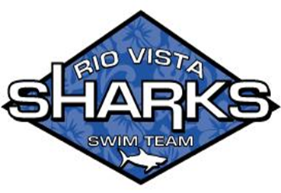

Swimmer(s) Name_______________________________

Instructions: Please complete all sections of this Opt-Out Form and return the signed form to the Rio Vista Sharks Board (swim office) within 15 days of your child’s first day of swim practice with the Rio Vista Sharks Swim Team.

STUDENT PHOTOGRAPHS, VIDEOS, AND/OR SOUND
RECORDINGS OPT-OUT
A parent may withhold permission to have a swimmer photographed, videotaped, and/
or audiotaped during swim team-sponsored activities, learning experiences, and/or media events. As the parent or guardian of the swimmer identified above, I understand that if I opt-out, my child will not be included in pictures taken by Swim Photographer, swimmers, parents, or anyone outside the pool, including commercial photographers and the media, nor will my child’s picture be part of a memory book, memory video, sportsteam, club, or any other medium.

If you do not want your child to be photographed, videotaped and/or audiotaped, check
the box below and sign:

🬀 DO NOT allow my child to be photographed, videotaped and/or audio taped during
swim--sponsored activities and/or learning experiences.

Parent Signature_________________________________________

Date ____________

